|  |  |  |  |  |  |  |  |  |  |  |
| --- | --- | --- | --- | --- | --- | --- | --- | --- | --- | --- |
| **Leeds University**  **Business School** | |  | | | | | | | | |
| **Dissertation/Project Coversheet** | | | | | | | | | | |
|  | | | | | | | | | | |
| Student ID Number: | 2 | | 0 | 1 | 5 | 9 | 6 | 9 | 1 | 8 |
| Student Name | 201596918 | | | | | | | | | |
| Module Code: | LUBS3302 | | | | | | | | | |
| Programme of Study: | Economics Joint Honours Final Year Project | | | | | | | | | |
| Supervisor: | Michael Reynolds | | | | | | | | | |
| Title: | Are they still together? Examining if the relationship between pay and productivity in the UK has transformed in recent decades. | | | | | | | | | |
| Declared Word Count: | 5565 | | | | | | | | | |
| Please Note:  Your declared word count must be accurate, and should not mislead. Making a fraudulent statement concerning the work submitted for assessment could be considered academic malpractice and investigated as such.  If the amount of work submitted is higher than that specified by the word limit or that declared on your word count, this may be reflected in the mark awarded and noted through individual feedback given to you.  It is not acceptable to present matters of substance, which should be included in the main body of the text, in the appendices (“appendix abuse”).  It is not acceptable to attempt to hide words in graphs and diagrams; only text which is strictly necessary should be included in graphs and diagrams. | | | | | | | | | | |
| By submitting an assignment you confirm you have read and understood the University of Leeds [**Declaration of Academic Integrity**](http://www.leeds.ac.uk/secretariat/documents/academic_integrity.pdf) ( <http://www.leeds.ac.uk/secretariat/documents/academic_integrity.pdf>). | | | | | | | | | | |

Are they still together?

Examining if the relationship between pay and productivity in the UK has transformed in recent decades.

Contents

Chapter 1: Introduction 5

Chapter 2: Previous Literature 11

Section 2.1: Decomposition Analyses 11

Section 2.2: Evidence of Productivity-pay Decorrelation 13

Section 2.3: Evidence of Productivity-pay Correlation 14

Section 2.4: Non-UK Productivity-pay Analyses 16

Chapter 3: Empirical Strategy 17

Section 3.1: Baseline Specification 17

Section 3.2: Alternative Specifications 18

Chapter 4: Data 19

Section 4.1: Summary Tables 20

Chapter 5: Data Analysis and Discussion 22

Section 5.1: Results 22

Table C – Median, mean, earnings and mean compensation regression results 22

Table D – Earnings percentiles 1-9 (less the median) regression results table. 23

Table E – Productivity elasticities from various different specifications. 24

Section 5.2: Discussion and analysis 24

Conclusion and Policy Implications 28

Appendix 34

Appendix I 34

Appendix II 37

Appendix III 38

# Chapter 1: Introduction

The relationship between productivity and living standards has often been taken as a stylised fact. Krugman (1990) writes,

“Productivity isn’t everything, but, in the long run, it is almost everything. A country’s ability to improve its standard of living over time depends almost entirely on its ability to raise its output per worker.”

However, the specific link between productivity and living standards is not straightforward, as Oulton (2022) points out. Despite this, the link is often implied, at least in part, through the pass-through of productivity growth on *earnings*, and the simple observation that higher earnings, all else equal, tend to boost living standards. This sentiment has been echoed by the Chancellor of the Exchequer Rachel Reeves in her 2024 *Mais Lecture*:

“At root, productivity remains the key medium term [sic] determinant of wages. It is the collapse in our productivity growth which explains our **wage stagnation**. […] What is demanded is a fundamental course correction. […] **Not only for the *living standards* of working people** …” (Reeves, 2024. Emphasis added)

Clearly, the link between productivity and pay, and thus productivity and living standards, has transcended beyond academic economics and gained acceptance in the political sphere. However, in recent years, a view that productivity and pay have ‘decoupled’, or ‘delinked’, has gained traction. The most recent embodiment comes in ‘The Productivity-Pay Gap’ diagram published by Bivens & Mishel (2015)[1], where American productivity is shown to have grown 8 times faster than pay from 1979 to 2014; see figure A.

Figure A – “Disconnect between productivity and a typical worker's compensation, 1948–2014”. (Bivens & Mishel, 2015. Figure A).

Returning to the UK, similar findings have been reported by Pessoa & Van Reenen (2013) and Teichgraeber & Van Reenen (2021). Figure B shows their estimation of the pay-productivity gap.

Figure B – “Hourly Decoupling in the UK” (Pessoa & Van Reenen, 2013. Figure 6)

A clear divergence can be ascertained in the early-mid 90s, and by 2010 median hourly earnings (deflated with retail prices) grew by 70% while productivity (deflated with a GDP deflator) grew by just over 110%.

Investigating the decoupling argument is complicated by the fact that exactly what is meant by ‘decoupling’ is hardly agreed upon, so clarification is important. Some parts of the literature argue that we should define decoupling as a divergence between typical worker compensation and mean productivity growth rates (Bivens & Mishel, 2015), while others suggest differentiating between mean and median earnings (Pessoa & Van Reenen, 2013; Stansbury & Summers, 2018; Ciarli, et al., 2018; Ciarli, et al., 2021); still others argue that decoupling should only be seen as a persistent fall in labour’s share of income (Feldstein, 2008; Brill et al., 2017); labour’s share of income is defined in national accounts as:

$$Labour share=\frac{Employee compensation+Self Employed Labour Income}{Gross Domestic Product-(Taxes-Subsidies)}$$

The view that decoupling is a change to the labour share is what led the Office for National Statistics (ONS) to state that, “[o]ver the last two-and-a-half decades […] the UK has not experienced the decoupling between pay and productivity reported in other advanced countries” (ONS, 2024). Indeed, labour’s share of income has risen in the new millenium following historic lows in the 80s and 90s – see figure C.

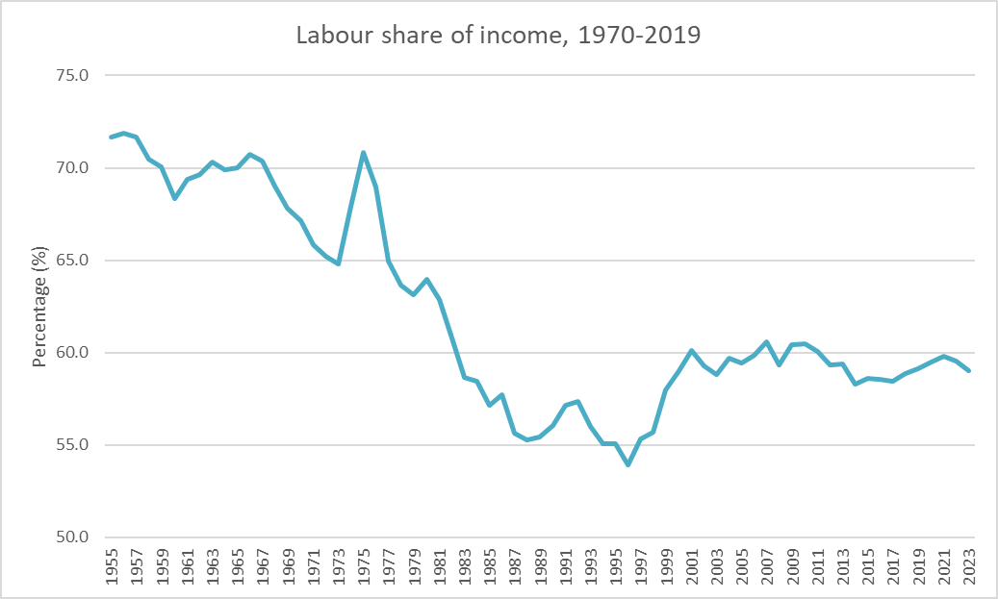

Figure C – Labour’s share of income over time. Own illustration. Source: ONS Labour Costs and Income (2025)

The disagreement over terms is understandable, because each argument for decoupling has certain justifications. Those concerned solely with the labour share analyse the productivity-pay question in the context of the production process – this perspective makes sense from the point of view of a firm, because it is employees’ compensation with respect to a firm’s output, *not* consumer prices, which reflect its real costs of employment (Feldstein, 2008; Stansbury & Summers, 2018, p. 10; Tuckett, 2017). Figure D shows how producer prices in the manufacturing and retail sector have grown slower than consumer prices – even if a firm’s output revenues were shared with employees in constant proportion, the real value of that payment could still be declining (Ngai & Sevinc, 2025).[2]

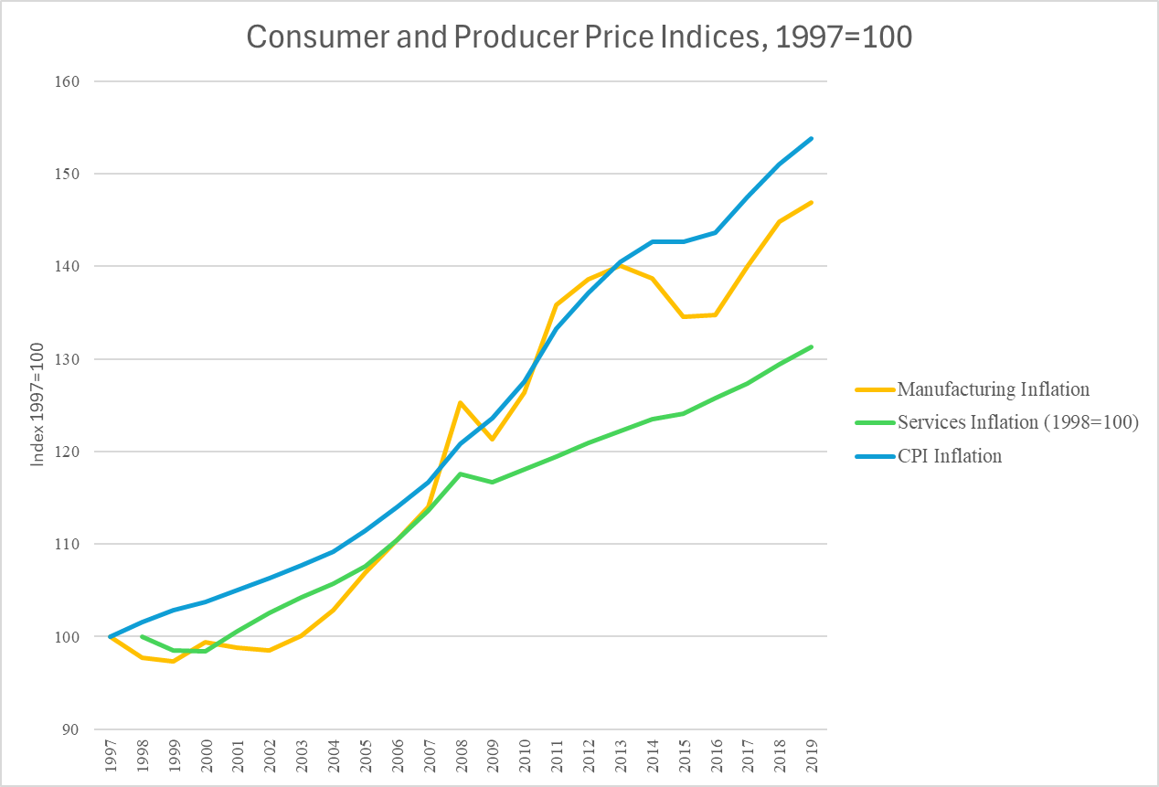

Figure D – Sectoral price inflation over time. Own illustration. Source: ONS CPI, SPPI and PPI (ONS, 2025)

On the other hand, ignoring the effect of productivity on purchasing power is not appropriate when investigating changes to living standards (Stansbury & Summers, 2018, p. 13; Pasimeni, 2018, p. 7). As such, to properly investigate the connection in the UK between living standards and productivity and the claim that they have either diverged or decorrelated I estimate the productivity elasticity across the income distribution. To investigate the stronger claim that inequality[3] is the principle cause of divergence, this paper also examines the impact of productivity on mean wages and compensation.

The paper proceeds as follows: Chapter 2 is a literature review divided into four sections – the first two focus on identifying two kinds of methodological problems prevalent within the productivity-pay literature in the UK, and how this study will add value by solving them. In the latter two sections, focus shifts to analyse the seminal papers which form the foundation of my empirical strategy. Chapter 3 outlines the empirical strategy, explains the rationale for robustness tests and sets out the alternative specification framework which will ensure confidence in final estimates. Chapter 4 explains where data was sourced and evaluates relationships and noticeable trends, discussing signs of potential structural breaks and changing income distributions.

Chapter 5 presents the results and reinforces the view that productivity has strong, positive links to living standards. Earnings across the income distribution, including mean earnings and compensation, are analysed to assess their correlation with productivity. Alternative specifications are put into practice so that a robustness sensitivity analysis can be performed. As a result, I find that productivity growth is very strongly correlated with wage growth at all levels of the income distribution. The analysis spans from 1997-2019 and utilises an OLS regression model to compare productivity and income growth, controlling for unemployment and inflation. At the median level, a 1% increase in productivity is associated with a 0.811% increase in earnings within two years, which rises to a 1.212% increase once five years have passed. Earnings growth with respect to productivity is higher for high earners, however, testing shows that up to and including the 8th decile of earners, the rate at which productivity growth increases wages is not statistically different from one-to-one. Inequality effects are real: the top decile benefit about 1.6 times more from productivity than the bottom 10%; furthermore, the coefficient for mean compensation growth is roughly 1.7 times greater than the median wage’s counterpart. While my research generally supports the views expressed by Krugman (1990) and Reeves (2024), i.e., that productivity is both an important determinant of wages, and that this relationship has been stable in recent decades, there are serious inequality and potential decoupling problems post-2008 which must be addressed via policy.

Finally, Chapter 6 discusses policy implications and concludes.

# Chapter 2: Previous Literature

The existing body of literature in the UK is sectioned broadly into decomposition analyses, evidence supporting a productivity-pay decorrelation, and evidence against. Finally, non-UK investigations are analysed which inform the empirical strategy.

## Section 2.1: Decomposition Analyses

Pessoa & Van Reenen (2013) and Teichgraeber & Van Reenen (2021) decompose the gap between median wages and productivity growth since the early 70s. They define net decoupling ($ND$) as the difference between labour productivity (LP) and mean compensation, both adjusted by an implicit GDP deflator. Gross decoupling ( $GD)$ is defined as the difference between LP and median wages, deflated by an output and consumer price deflator, respectively. In recent years, $GD$ has been growing larger and larger – that is what we see in figure B – but $ND$ has stayed relatively stable.

The difference between the two measures can be decomposed to:

$$\begin{aligned}GD-ND=Inequality+Wage wedge+Price wedge\#\left(1\right)\end{aligned}$$

Equation 1 explains nearly the entire difference $GD-ND$, although Pessoa & Van Reenen (2013) explain that measurement errors and the labour income of the self-employed also account for a very small proportion. $Inequality$ represents differences between mean and median wages, $Wage wedge$ represents differences between wages and total compensation per hour, i.e., non-wage benefits such as pensions, and $Price wedge$ represents differences between producer and consumer prices. See Figures E and F for a decomposition of the gap.

Figure E – “Decoupling Decomposition in the UK” Pessoa & Van Reenen (2013, p. 18. Figure 7)

Figure F – “Decoupling Decomposition in the UK” Teichgraeber & Van Reenen (2021, p. 41. Chart 5)

We see from both figures that the divergence in productivity-pay is mostly a growth in inequality and non-wage compensation. As Teichgraeber & Van Reenen (2021) point out, however, non-wage benefits are themselves likelier to accrue to high earners.  
My main criticism of both studies and others like them (Bivens & Mishel, 2015; Tuckett, 2017) is the methodology which is used to make certain claims. For example, Van Reenen states that the findings of T&VR (2021) reinforces the idea the UK needs to “tackle this productivity [growth] challenge if we want to get back to sustainable earnings growth.” (LSE News, 2021) However, if that is the main message of the study, it doesn’t seem to be getting through – on the same website, it is claimed the study shows “the typical worker may not feel much benefit [from productivity growth]”. This apparent contradiction owes itself to the lack of quantitative backing possessed by graphical depictions of the productivity-pay divergence. Readers are left to guess whether the productivity-pay causal link is broken, or binding but visually diverging due to orthogonal factors (Stansbury & Summers, 2018, p. 4).

## Section 2.2: Evidence of Productivity-pay Decorrelation

Ciarli et al. (2018) use matched employer-employee combinations to investigate how low-wage workers benefit from productivity growth in the UK from 2011-15. Their methodology allows the study of effects at the firm, industry, and local labour market level. Their work builds on a similar methodology by Carlsson (2016) who found that Swedish workers in 1990-96 gained greater benefit at the *industry level* from productivity improvements than at the *firm level*, meaning that productivity improvements in the firm employing them raised their wages less than productivity improvements in rival firms. Ciarli et al. (2018, p. 16) similarly report stronger effects at broader compared to narrower levels. Productivity growth effects on median wages were insignificant at the firm level, -0.040% at the industry level, and insignificant at the local labour market (LLM) level. Furthermore, most income quintiles experience insignificant wage growth due to productivity growth.

These findings are mirrored by Ciarli et al. (2021) who investigate the productivity-compensation nexus in London, Slough & Heathrow, and the rest of Great Britain at the LLM level in the period 2004-2014. The researchers employ a 2SLS regression, as endogeneity problems may arise between wages and productivity – for example, minimum wage increases may spur firms to increase productivity. They instrument using firms’ technical productivity, as capital investment is less likely to be influenced by changes to minimum wages, and control for matched employer-employee fixed effects, and year fixed effects. They find statistically significant productivity elasticities of median wages of 0.35% and 0.26%, at the 5-year and 10-year time horizons, respectively.

These two papers suggest strong productivity-pay decorrelation in the UK; however, I believe there are significant potential methodological improvements; for example, Ciarli et al. (2018, p. 15) point out that their findings do not capture lagged effects of productivity, which are likely biasing results. The authors themselves state that firms may postpone wage increases to gain a competitive advantage or to recover from losses, and Carlsson (2016) – one of their seminal papers – does include lagged effects in his model. It is also likely that firms deliberate to discern the extent to which increases in output are due to labour productivity (Stansbury & Summers, 2018). This problem remains unaddressed in Ciarli et al. (2021).

## Section 2.3: Evidence of Productivity-pay Correlation

Brocek (2019) is the only work, to my knowledge, which analyses productivity elasticities across the income distribution with lagged effects. Brocek (2019) runs separate OLS regressions for each decile of the wage distribution on productivity. Current and lagged unemployment is controlled for, as economic downturns are likely correlated with reduced wages in the short-term (Stansbury & Summers, 2018, p. 15) and increased productivity, given that unproductive workers are likely laid off first, and firms must make-do with less (Lazear, et al., 2016). All variables are taken in their 3-year moving average (MA) forms to analyse lagged effects (Stansbury & Summers, 2018; Brocek, 2019; Pasimeni, 2018). Brocek’s (2019) results are presented in figure G.

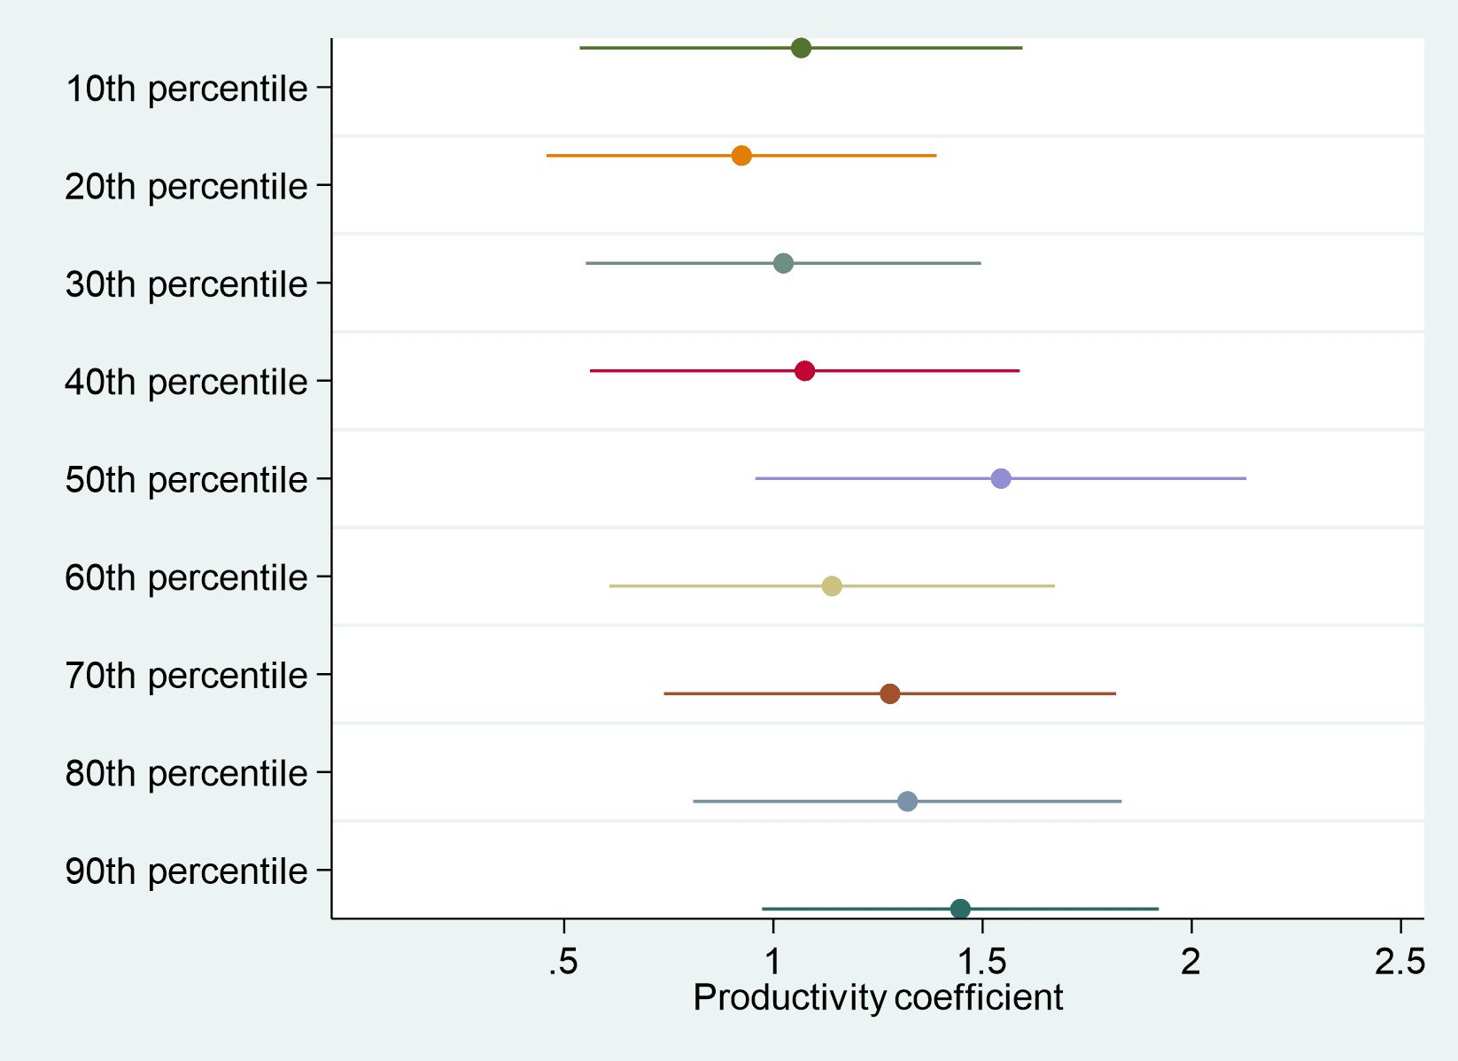

Figure G – “Estimates of [productivity elasticities] across the wage distribution” Brocek (2019, Figure 2)

Brocek (2019) finds strong productivity elasticities at the median level; none of the estimated coefficients are significantly different from 1 and are all significantly different from 0. However, I contend Brocek’s (2019) study is hindered by: lack of testing, opaqueness of techniques, and data handling, as well as potentially omitted variable bias (OVB) and smallness of scope. I explore next.

Nasir et al. (2022) regress using a NARDL multiplier analysis to investigate mean weekly earnings with respect to productivity and GDP growth, controlling for inflation and unemployment; controlling for inflation is a novel contribution to the productivity-pay literature and takes into account its potential confounding effect given its negative relationship with real wages (Braumann, 2001) and its detrimental effects on productivity – high inflation tends to shift output from the productive to financial sector (Mishkin & Posen, 1997, p. 4). It is also important when determining wages due to conflict-theories of inflation which lay the foundations for an understanding of price-wage and wage-price spirals, as well as the mechanism of inflationary expectations (Blanchard, 2004; Blanchard, 2022; Rowthorn, 2024). Nasir et al.’s (2022) NARDL multiplier analysis finds that wages are very sticky downward, with the long-run difference between a positive and negative shock of 1% being roughly equal to 1%.

## Section 2.4: Non-UK Productivity-pay Analyses

Stansbury & Summers (2018) calculate productivity elasticities for median and mean compensation, as well as production/non-supervisory average compensation, which is a dataset unavailable in the UK but which closely tracks the median compensation figure while providing an improved time horizon (Stansbury & Summers, 2018, p. 12). Like Brocek (2019), Stansbury & Summers (2019) control for lagged and current unemployment, and use 3-year MAs to capture delayed effects of productivity[4]. Productivity elasticities are estimated as 0.7-1% for median and mean compensation growth and 0.4-0.7% for production/non-supervisory compensation growth.

Pasimeni (2018) is inspired by the Stansbury & Summers (2018) methodology and performs a panel-data fixed effects regression on 34 advanced economies. Again, unemployment is controlled for, although this time it is the in levels[5] and differenced rate, and variables are taken as 3-year MAs and estimates are tested for robustness by substituting with distributed lag models. Pasimeni (2018, p. 12) reports weaker correlations than Stansbury & Summers (2018) with no coefficients crossing the 1% line at a 95% confidence level, however all productivity elasticities across specifications are significant.

# Chapter 3: Empirical Strategy

This paper’s empirical strategy mainly follows Stansbury & Summers (2018), Pasimeni (2018) and Brocek (2019), controlling for employment and one-period lagged unemployment and incorporating inflation as a novel control variable from Nasir et al. (2021) to reduce omitted-variable bias. As in the literature, an OLS model is used to regress productivity and earnings growth across the income distribution and the growth of mean compensation. Three-year moving averages are used to capture lagged effects, although a distributed-lags model will be introduced in Section 3.2 to double-check estimates.

## Section 3.1: Baseline Specification

Equation (1) shows our baseline specification.

$$\begin{aligned}\frac{1}{3}\sum_{0}^{2}{Δ\log{wages_{n,t-i}}}=β_{0}+β_{1}\frac{1}{3}\sum_{0}^{2}{Δlog{prod_{t-i}}}+β_{2}\frac{1}{3}\sum_{0}^{2}{unemp_{t-i}}+β_{3}\frac{1}{3}\sum_{0}^{2}{unemp_{t-i-1}+β_{4}\frac{1}{3}\sum_{0}^{2}{inf_{t-i}}+ϵ_{t}}\#\left(1\right)\end{aligned}$$

Where $wages_{n,t}$ is the $n$ th decile, $prod_{t}$ is labour productivity, $unemp_{t}$ is unemployment, $inf_{t}$ is inflation and $ϵ_{t}$ is the error term – all variables are expressed at a given year $t$.

Wages and productivity are logged to calculate elasticities and reduce variability. Following unit-root tests, wages and productivity were differenced to ensure stationarity – see Appendix I – meaning estimates are less biased and more efficient.

Our baseline regression will use net labour productivity to discount the value of depreciated capital from total output to better reflect the income available for workers (Bivens & Mishel, 2015; Stansbury & Summers, 2018, p. 11) The 25-49yr-old unemployment rate is also preferred to avoid capturing broader effects of demographic shift which may bias results (Stansbury & Summers, 2018, p. 15). The consumer price index (CPI) is preferred to CPI plus housing (CPIH) because CPI is the headline rate targeted by the Bank of England (BoE) (Nasir, et al., 2022). Finally, all models are regressed using robust standard errors.

## Section 3.2: Alternative Specifications

Following Pasimeni (2018) and Stansbury & Summers (2018), and improving on Brocek (2019), this study uses alternative specifications to check for the robustness of estimates. The main robustness check is the choice removal and addition of different variables from the baseline specification model to check that our core variable, productivity, has an insensitive relationship to earnings and compensation. As Lu & White (2014) make clear, this kind of robustness is necessary for valid causal inference, however lack of experience can lead to a false belief in having done due diligence. For this reason, I will borrow heavily from existing literature. The clearest robustness test is Stansbury & Summers (2018) page 23, Table 2. They check:

* Unemployment,
* Time trends,
* Decade dummy variables,
* Contemporaneous time,
* 2-to-4-to-5 year moving averages.

While closely mirroring this, I decided not to include time trends or decade dummy variables because of these studies focus on a different time horizon. Instead, borrowing from Brocek (2019) and Nasir et al., (2021), a dummy variable will be used to examine a structural break in the time series. The Clemente-Montañés-Reyes unit-root test noted a statistically significant breakpoint around 2007-8 – see Appendix I. The dummy will be set equal to 1 prior to 2008, and 0 during and afterward; see equation (2).



By using dummies, the effect of the 2008 financial crisis on the pay-productivity link can be analysed.

Additional specifications will focus on substituting variable data for less theoretically appealing kinds, e.g., GDP substituted for NDP; this helps to assess the sensitivity of the productivity-pay relationship.

# Chapter 4: Data

The data analysed in this study is primarily provided by the Office for National Statistics (ONS) and is analysed over the timeframe 1997-2019. Earnings distribution data is taken directly from the Annual Survey of Hours and Earnings (ASHE) (ONS, 2024) and deflated using CPI (ONS, 2025). Different productivity specifications are calculated by aggregating various ONS sources and can be found in Table B – see Appendix II for aggregation methodology. The restricted unemployment figure was calculated using the UNEM01 ONS (2025) dataset – see Appendix III.

## Section 4.1: Summary Tables

**Table A: Dependent Variables**

|  |  |  |  |  |  |  |
| --- | --- | --- | --- | --- | --- | --- |
| Income variable[6] | Obs. | Mean | Std. Dev. | Median | Min | Max |
| Hourly Earnings 1st | 23 | 6.72 | 0.59 | 6.77 | 5.44 | 7.75 |
| Hourly Earnings 2nd | 23 | 7.74 | 0.54 | 7.81 | 6.53 | 8.52 |
| Hourly Earnings 3rd | 23 | 8.91 | 0.55 | 8.99 | 7.62 | 9.58 |
| Hourly Earnings 4th | 23 | 10.20 | 0.61 | 10.30 | 8.76 | 10.98 |
| Median Hourly Earnings | 23 | 11.78 | 0.71 | 11.92 | 10.09 | 12.73 |
| Hourly Earnings 6th | 23 | 13.79 | 0.85 | 14.00 | 11.75 | 14.95 |
| Hourly Earnings 7th | 23 | 16.37 | 1.04 | 16.64 | 13.85 | 17.74 |
| Hourly Earnings 8th | 23 | 19.88 | 1.29 | 20.13 | 16.80 | 21.63 |
| Hourly Earnings 9th | 23 | 25.99 | 1.78 | 26.30 | 21.81 | 28.31 |
| Mean Hourly Earnings | 23 | 15.33 | 1.05 | 15.62 | 12.70 | 16.62 |
| Mean Hourly Compensation | 23 | 18.63 | 1.64 | 19.13 | 14.65 | 20.76 |

**Table B: Independent Variables**

|  |  |  |  |  |  |  |
| --- | --- | --- | --- | --- | --- | --- |
| Variable Name | Obs. | Mean | Std. Dev. | Median | Min | Max |
| Net Productivity, NDP | 23 | 28.77 | 1.65 | 29.40 | 24.85 | 30.41 |
| Net Productivity, NVA | 23 | 32.66 | 1.98 | 33.57 | 27.92 | 34.76 |
| Gross Productivity, GDP | 23 | 34.10 | 2.22 | 35.14 | 28.97 | 36.48 |
| Gross Productivity, GVA | 23 | 37.99 | 2.56 | 39.25 | 32.05 | 40.83 |
| Unemployment, 25-49yr | 23 | 4.56% | 1.09% | 4.16% | 2.83% | 6.37% |
| Unemployment, unrestricted | 23 | 5.81% | 1.28% | 5.40% | 3.80% | 8.10% |
| Inflation, CPI | 23 | 1.93% | 0.96% | 1.85% | 0.00% | 4.28% |
| Inflation, CPIH | 23 | 2.00% | 0.77% | 2.00% | 0.40% | 3.80% |

Tables A and B provide summary statistics of the variables used in the regression. We find inflation hovering just below the BoE’s 2% target and a 5.81% unrestricted unemployment rate, indicating a moderately loose labour market over the period. The relatively huge jump of an average extra £6.11/hour going from the 8th to 9th decile and the rising standard deviation up the income distribution indicates strongly that high earners’ earnings have grown quickly in absolute terms. On the other hand, lower earners have seen their income grow by the most as a percentage – see figure H.

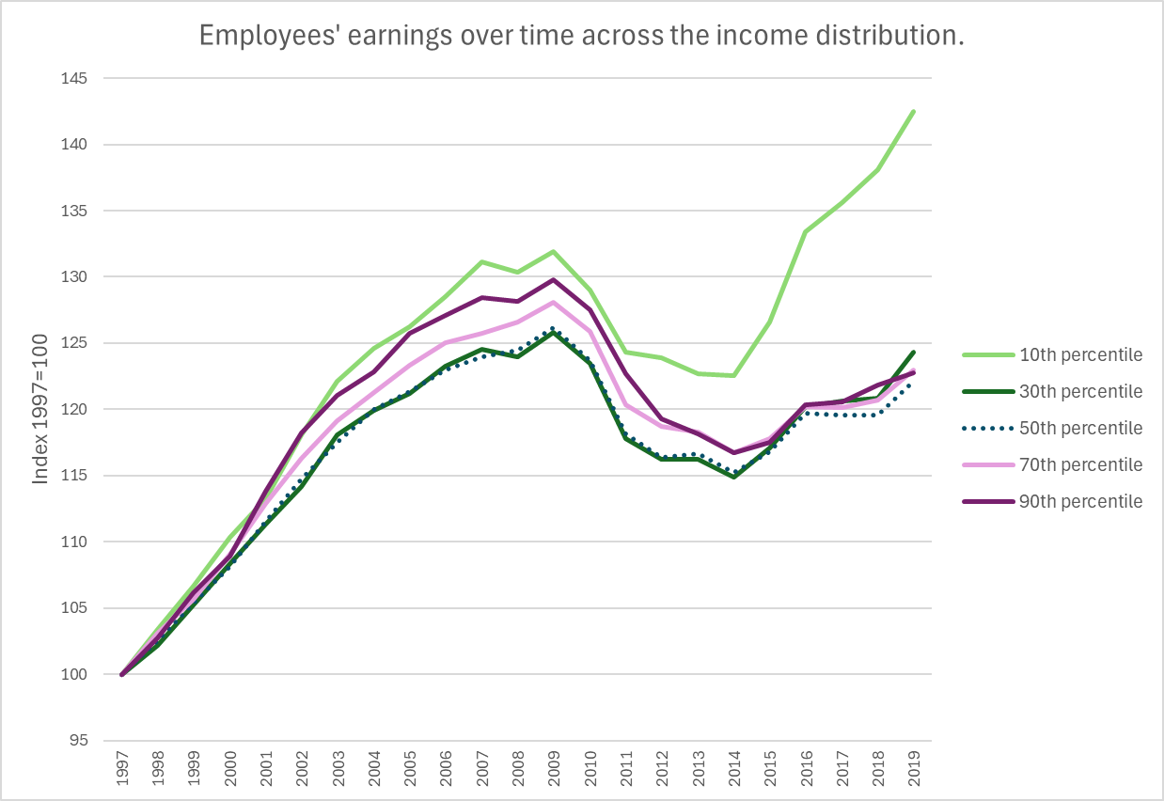

Figure H – Employees’ earnings over time, 1987=100. Own illustration. Source: ASHE (ONS, 2024)

# Chapter 5: Data Analysis and Discussion

## Section 5.1: Results

### Table C – Median, mean, earnings and mean compensation regression results

|  |  |  |  |
| --- | --- | --- | --- |
|  | (1) | (2) | (3) |
| Variables | Median Earnings | Mean Earnings | Mean Compensation |
| $$\frac{1}{3}\sum_{0}^{2}{Δ{\log{prod}}_{t}}$$ | **1.047\*\*\***  (0.139) | **1.429\*\*\***  **(0.183)** | **1.800\*\*\***  **(0.164)** |
| $$\frac{1}{3}\sum_{0}^{2}{{unemp}_{t}}$$ | 0.414  (0.490) | 0.932  (0.531) | 0.819*  (0.394) |
| $$\frac{1}{3}\sum_{0}^{2}{{unemp}_{t-1}}$$ | **-0.984\*\***  (0.433) | **-1.408\*\***  **(0.483)** | **-1.513\*\*\***  **(0.376)** |
| $$\frac{1}{3}\sum_{0}^{2}{\inf_{t}}$$ | **-1.160\*\*\***  (0.282) | **-1.189\*\*\***  **(0.317)** | **-1.104\*\*\***  **(0.306)** |
| **Constant** | **0.057\*\*\***  (0.012) | **0.052\*\*\***  **(0.014)** | **.0584\*\*\***  **(0.011)** |
| **F-test**§ | 0.11 | 5.51 | **23.70\*\*\*** |
| **R^2** | 0.879 | 0.859 | 0.921 |
| *Note:* dependent variables are in three-year moving average, logged, differenced form.  §Null hypothesis is that coefficients are equal to 1.  Robust standard errors in parentheses.  **\*\*\* p<0.01**,**\*\* p<0.05**, * p<0.1 | | | |

### Table D – Earnings percentiles 1-9 (less the median) regression results table.

|  |  |  |  |  |  |  |  |  |
| --- | --- | --- | --- | --- | --- | --- | --- | --- |
|  | $β_{n}$-coefficients | | | |  | |  | |
| Dependent Variable | $$Δprod_{t}$$ | $$unemp_{t}$$ | $$unemp_{t-1}$$ | $$inf_{t}$$ | **Constant** | **F-test§** | | **R^2** |
| $$\frac{1}{3}\sum_{0}^{2}{Δ{\log{wage}}_{1,t}}$$ | **0.877\*\*\***  **(0.181)** | **-0.950\*\***  **(0.380)** | 0.104  (0.372) | **-1.052\*\*\***  **(0.222)** | **0.074\*\*\***  **(0.011)** | 0.46 | | 0.888 |
| $$\frac{1}{3}\sum_{0}^{2}{Δ{\log{wage}}_{2,t}}$$ | **0.838\*\*\***  **(0.125)** | -0.397  (0.366) | -0.409  (0.326) | **-1.128\*\*\***  **(0.194)** | **0.071\*\*\***  **(0.008)** | 1.68 | | 0.920 |
| $$\frac{1}{3}\sum_{0}^{2}{Δ{\log{wage}}_{3,t}}$$ | **0.971*** (0.121)** | 0.069  (0.400) | -0.748* (0.356) | **-1.125*** (0.233)** | **0.062*** (0.010)** | 0.06 | | 0.9115 |
| $$\frac{1}{3}\sum_{0}^{2}{Δ{\log{wage}}_{4,t}}$$ | **1.022*** (0.141)** | 0.197  (0.474) | -0.815* (0.423) | **-1.052*** (0.267)** | **0.056*** (0.011)** | 0.02 | | 0.8797 |
| $$\frac{1}{3}\sum_{0}^{2}{Δ{\log{wage}}_{6,t}}$$ | **1.129*** (0.149)** | 0.612 (0.527) | **-1.157** (0.469)** | **-1.114*** (0.290)** | **0.054*** (0.012)** | 0.75 | | 0.8695 |
| $$\frac{1}{3}\sum_{0}^{2}{Δ{\log{wage}}_{7,t}}$$ | **1.229*** (0.158)** | 0.712 (0.531) | **-1.263** (0.475)** | **-1.100*** (0.292)** | **0.054*** (0.013)** | 2.10 | | 0.8713 |
| $$\frac{1}{3}\sum_{0}^{2}{Δ{\log{wage}}_{8,t}}$$ | **1.292*** (0.146)** | 0.928* (0.500) | **-1.501*** (0.447)** | **-1.231*** (0.267)** | **0.057*** (0.011)** | 4.02* | | 0.8986 |
| $$\frac{1}{3}\sum_{0}^{2}{Δ{\log{wage}}_{9,t}}$$ | **1.374*** (0.140)** | **0.954** (0.418)** | **-1.632*** (0.382)** | **-1.329*** (0.241)** | **0.065*** (0.011)** | **7.18\*\*** | | 0.9200 |
| *Note:* independent variables are in three-year moving average form, and logged and differenced as baseline specification indicates.  §Null hypothesis is that coefficients are equal to 1.  Robust standard errors in parentheses  **\*\*\* p<0.01**,**\*\* p<0.05**, * p<0.1 | | | | | | |  | |

### Table E – Productivity elasticities from various different specifications.

|  |  |  |  |  |  |  |  |  |  |
| --- | --- | --- | --- | --- | --- | --- | --- | --- | --- |
|  | | (1) | | (2) | | | (3) | | |
| Alternative Specification | | Median Earnings | | Mean Earnings | | | Mean Compensation | | |
| A1 | Without unemployment | **0.995\*\*\***  (0.190) | | **1.291\*\*\***  (0.242) | | | **1.687\*\*\***  (0.232) | | |
| A2 | Without inflation | **0.984\*\*\***  (0.190) | | **1.364\*\*\***  (0.220) | | | **1.740\*\*\***  (0.222) | | |
| A3 | With pre-2008 dummy variable╬ | -0.204  (0.420) | **1.147\*\***  **(0.397)** | | 0.290  (0.558) | 1.044*  (0.531) | | .755*  (0.430) | **.958\*\***  **(0.355)** |
| A4 | Contemporaneous | **0.621\*\*\***  **(0.200)** | | **0.827\*\*\***  **(0.245)** | | | **1.486\*\*\***  **(0.242)** | | |
| A5 | Contemporaneous w/o inflation | 0.320  (0.229) | | **0.543\*\***  **(0.255)** | | | **1.164\*\*\***  **(0.339)** | | |
| A6 | 2-year moving average | **0.811\*\*\***  **(0.190)** | | **1.109\*\*\***  **(0.236)** | | | **1.627\*\*\***  **(0.215)** | | |
| A7 | 4-year moving average | **1.165\*\*\***  **(0.104)** | | **1.552\*\*\***  **(0.142)** | | | **1.892\*\*\***  **(0.124)** | | |
| A8 | 5-year moving average | **1.212\*\*\***  **(0.094)** | | **1.601\*\*\***  **(0.131)** | | | **1.930\*\*\***  **(0.103)** | | |
| A9 | Net Productivity (NVA) | **1.180\*\*\***  **(0.122)** | | **1.587\*\*\***  **(0.174)** | | | **1.950\*\*\***  **(0.176)** | | |
| A10 | Gross Productivity (GVA) | **1.220\*\*\***  **(0.119)** | | **1.657\*\*\***  **(0.154)** | | | **2.001\*\*\***  **(0.161)** | | |
| A11 | Gross Productivity (GDP) | **1.108\*\*\***  **(0.127)** | | **1.521\*\*\***  **(0.158)** | | | **1.882\*\*\***  **(0.142)** | | |
| A12 | Unrestricted employment | **0.956\*\*\***  **(0.139)** | | **1.327\*\*\***  **(0.185)** | | | **1.682\*\*\***  **(0.164)** | | |
| A13 | CPIH-based inflation | **0.830\*\*\***  **(0.191)** | | **1.228\*\*\***  **(0.236)** | | | **1.604\*\*\***  **(0.202)** | | |
| *Note:* unless stated otherwise, variables modelled as baseline specification.  Robust standard errors in parentheses.  **\*\*\* p<0.01**,**\*\* p<0.05**, * p<0.1  ╬ *Red number in right-hand box is dummy-interaction coefficient.*  *Cells that cannot reject the $H_{0}: β=1$ F-test at the 5% significance level are shaded grey.* | | | | | | | | | |

## Section 5.2: Discussion and analysis

The estimated results are very closely in line with those reported in similar studies (Stansbury & Summers, 2018; Brocek, 2019; Pasimeni, 2018). The productivity-pay relationship is clearly very robust to specification changes: median wages almost always retain growth rates statistically indistinguishable from one-to-one throughout all robustness tests. The evidence does not support the conclusions found in Ciarli et al. (2018) or Ciarli et al. (2021) where a statistically insignificant, or sometimes negative, elasticity between earnings and productivity is estimated.

The income distribution and productivity coefficients are plotted on figure I.

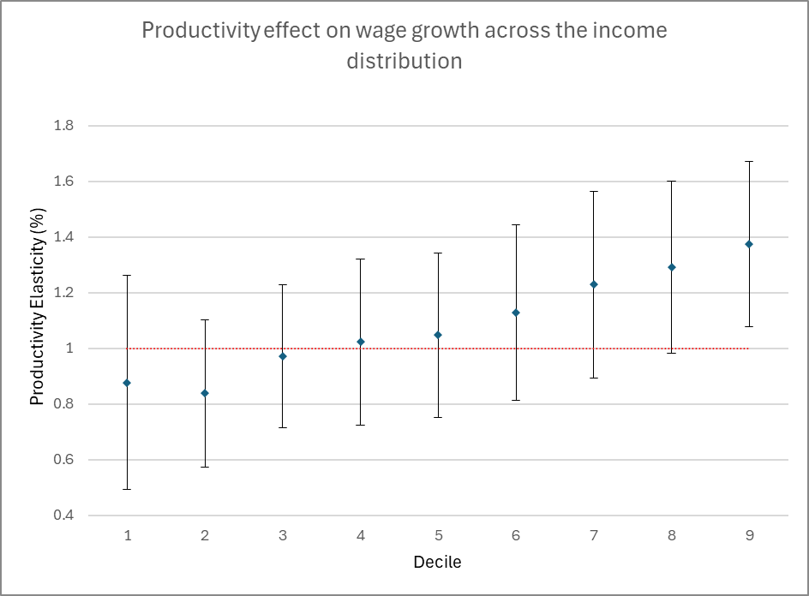

Figure I – Marginal effects of productivity on wage growth. Own illustration. Data from Table D. Red-dotted line shows elasticity of 1.

Figure I clearly depicts inequality effects, but also is good news for lower income earners – benefits from productivity gain do not skip or miss any income group.

Despite what might initially be thought, productivity growth, on average, confers the greatest advantage to mean compensation. This result may seem surprising – from Table A, we know that the top 20% of wage-earners earn more than the average employee’s combined wage and non-wage benefits; so, why do productivity benefits confer more to the average employee? The reality is that the benefit is not going to the average employee – it’s going to recipients of non-wage benefits, one of Teichgraeber and Van Reenen’s (2021) main findings. Because the compensation-wage coefficient differential is so large – even in alternative specifications where the marginal benefit to mean compensation is likely underestimated, e.g., using two-year moving-averages – average compensation still experiences a 18% bigger benefit from productivity growth than the highest earners’ wages. These results lends strong credibility to the idea that a large part of productivity is going toward expanding non-wage benefits.

Another very important result is the dummy interaction alternative specification on Table E. Almost all post-2008 coefficients are insignificant, save for mean compensation at a 10% significance level. Generating broad conclusions based on this regression is ill-advised, because the small sample sizes on either side of the year 2008 can lead to spurious correlation; however, it does provide an indication of the magnitude of the breakdown between median earnings and productivity after 2008. Figure J shows what happens when the entire income distribution is regressed against a dummy-variable interaction term as in Table E.A3, and then only the pre-2008 dummy coefficients are plotted.

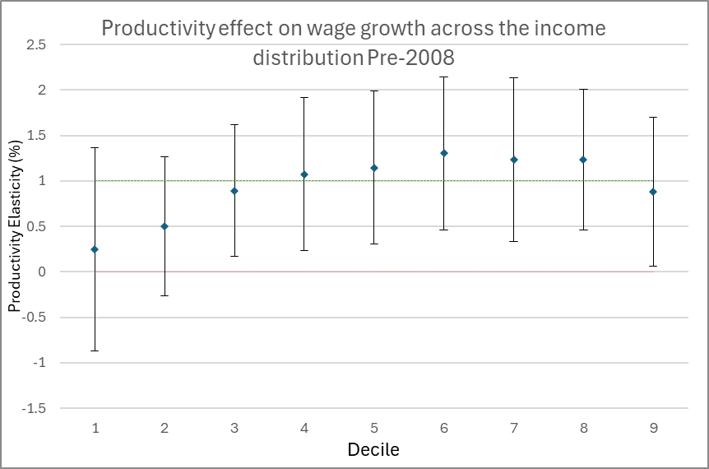

Figure J – Marginal effects of productivity on wage growth pre-2008. Own illustration. Data from Table D. Red-dotted line shows elasticity of 0, green-dotted line shows elasticity of 1.

It strongly indicates that the middle classes, i.e., between the bottom 30% to the top 40%, were the biggest beneficiaries of productivity growth before 2008. Figure K, on the other hand, represents what happens when the post-2008 leftover coefficients are plotted.

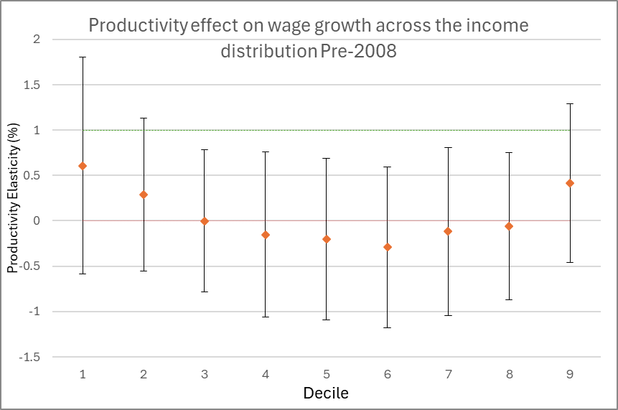

Figure K – Marginal effects of productivity on wage growth post-2008. Own illustration. Data from Table D. Red-dotted line shows elasticity of 0, green-dotted line shows elasticity of 1.

To reiterate, the sample size of 11 years post-2008 means that such estimates have to be taken with a grain of salt. However, the fact that none of the middle-class error bars even approximate the one-to-one relationship is troubling for economists in the Krugman (1990) and Reeves (2024) boat. More analysis is necessary before strong claims are made. In the meantime, this evidence should be taken along with the preponderance of evidence from Tables C, D and E that points to a strong, robust link between median wages and productivity.

Finally, while it’s clear that productivity is a very significant determinant of wages, so is unemployment and inflation. The fact that lower decile wages seem to be negatively correlated with a $t$-time – as opposed to $t-1$-time – unemployment shock indicates the greater exposure that lower earners have to recessions.

# Conclusion and Policy Implications

Pay and productivity appear to have decoupled around the world. Clear divergence was captured through graphical and numeric decomposition methods exemplified by Pessoa & Van Reenen (2013) in the UK and Bivens & Mishel (2015) in the US. A strong literature emerged, questioning whether the long-established link, exemplified most clearly in Krugman’s 1990 statement that productivity is, in the long run, “almost everything”, had broken. This study presents a strong case that productivity and income have not delinked or decorrelated, even while they have undoubtedly diverged. This study finds that the link between productivity and median earnings is robust to a plethora of different assumptions and specifications. Importantly, for most people, the *rate at which productivity growth increases wages is not statistically different from one-to-one*.

On the other hand, there are specific problems identified by the study which are yet to be tackled with adequate policy.

First, inequality effects are strong. While the bottom 80% of people can reasonably expect a one-to-one increase between average productivity and their wages, the top 20% can expect closer to a 1.5-to-one pay-off. Given that higher earners are the main recipients of non-wage benefits already, an outsized portion of productivity is going toward those who are already earning much more than the median employee. Whether this is due to uncompetitive rent-seeking by capital-owners, or simply a reflection of unequal labour productivity distribution, is still an open question. What is clear, is that while improvements to average labour productivity benefit everyone, they benefit top earners more. While these findings cast doubt on the drive to de-emphasise the importance of increasing productivity, they also give further credence to worries about increasing income inequality. Inequality will increase if productivity is targeted, simply because the productivity elasticity of mean wages is greater than that of median wages. Smart policy should therefore get ahead of negative consequences by pairing productivity enhancing policy with redistributive policy too, such as changes to income tax.

Second, this study finds that productivity elasticities have weakened since around 2008, directly answer the question of *if* the typically stable relationship between pay and productivity has changed over recent decades. While statistical power in this aspect was weak and so the exact extent of that decorrelation is difficult to ascertain, strong steps must be taken to relink productivity and pay. To this end, the OECD (2017) suggests active labour market policies to prevent long-term unemployment and competitive environments to align wages to the marginal product of labour. Ngai & Sevinc (2025) raise the important point that if your sector prices rise slower than consumer prices, even a greater share of the marginal product of labour could potentially lead to a loss of income – this was the crux of Figure D in Chapter 1.

Moving on, it is clear that there must be some broader policy prescriptions set out besides raising productivity given that there remain orthogonal factors to wages and productivity which cause visible divergence even while not impacting statistical correlation. What exactly these “orthogonal factors” are is not yet fully settled – Stansbury & Summers (2018) suggest a few competing hypotheses, such as technological progress, education and skills, globalisation, or the broad decline of worker power.

The worker/bargaining power hypothesis is growing in popularity as a policy response to reduced rent-sharing from capital-owners to workers (Bell, et al., 2019). Nasir et al. (2022) suggest that a characteristic lack of worker bargaining power is the best explanation for slow wage growth in the UK retail sector, for example. Pasimeni (2018, p. 19) furthers the bargaining power hypothesis by arguing that unemployment elasticities can be used as a proxy to capture changing labour bargaining power like in efficiency wages theories (Stiglitz & Shapiro, 1984; Akerlof & Yellen, 1990). The consistently significant negative lagged employment elasticities in Table C supports this idea.

Combining these theories and the collected evidence, it should be clear that while productivity is probably the most important factor which needs to rise to increase earnings and living standards, full employment must also be closely targeted to ensure gains from productivity are not lost due to low bargaining power.

To surmise – this study’s findings reinforce the importance of the productivity-pay relationship in the policy debate, and cast doubt on prior suggestions to de-emphasise it relative to redistributive policies. The policy implications of such a recently damaged relationship is to focus on restoring links, possibly through active labour market institutions or more competitive markets (OECD, 2017). Furthermore, the productivity-pay nexus has, according to this study, serious and demonstrable effects on inequality – high earners benefit 1.6 times more than the lowest earners – and the average total compensation packet benefits almost 1.7 times as much than the median wage packet – from productivity boosts. And yet, even given such inequality, productivity growth still remains the best way to raise the living standards of broad bases of people. Policymakers therefore must act fast in balancing the good with the bad and making sure that pay and productivity never break up again.

# Bibliography

Bank of England, 2024. *Research datasets.* [Online]   
Available at: https://www.bankofengland.co.uk/statistics/research-datasets

Barth, E., Bryson, A. & Dale-Olsen, H., 2017. *Union Density, Productivity, and Wages,* s.l.: NIESR.

Baum, C. F., 2018. *CLEMAO_IO: Stata module to perform unit root tests with one or two structural breaks,* s.l.: Boston College Department of Economics.

Bell, B., Bukowski, P. & Machin, S., 2019. *Rent Sharing and Inclusive Growth,* s.l.: LSE.

Bivens, J. & Mishel, L., 2015. *Understanding the Historic Divergence Between Productivity and a Typical Worker’s Pay,* s.l.: Economic Policy Institute.

Bivens, J. & Mishel, L., 2017. *New paper on pay-productivity link does not overturn EPI findings.* [Online]   
Available at: https://www.epi.org/blog/new-paper-on-pay-productivity-link-does-not-overturn-epi-findings/

Blanchard, O., 2004. *Explaining European Unemployment,* s.l.: NBER.

Blanchard, O., 2022. *Olivier Blanchard.* [Online]   
Available at: https://x.com/ojblanchard1/status/1608967176232525824

Braumann, B., 2001. *High Inflation and Real Wages,* s.l.: IMF.

Brill, M. et al., 2017. *Understanding the labour productivity and compensation gap,* s.l.: Bureau of Labour Statistics.

Brocek, F., 2019. *Is the link between labour productivity and wage growth still alive in the UK?.* [Online]   
Available at: https://fraserofallander.org/link-labour-productivity-wage-growth-uk/

Carlsson, M., Messina, J. & Skans, O. N., 2016. Wage Adjustment and Productivity Shocks. *The Economic Journal,* 126(595), pp. 1739-1773.

Casanova, J. & Andrés, C. G., 2014. *Twentieth-Century Spain: A History,* Cambridge: Cambridge University Press.

Ciarli, T., Di Ubaldo, M. & Savona, M., 2021. *The weak link between productivity and wages in London: Evidence from firms and local labour markets (2004-2014),* London: The Greater London Authority.

Ciarli, T., Salgado, E. & Savona, M., 2018. *Do Low-Wage Workers Benefit from Productivity Growth Recovery?,* s.l.: Joseph Rowntree Foundation.

Doucouliagos, C. & Laroche, P., 2003. What do Unions do to Productivity? A Meta-Analysis. *Industrial Relations,* pp. 650-691.

Feldstein, M., 2008. Did wages reflect growth in productivity?. *Journal of Policy Modeling,* pp. 591-594.

Gabaix, X., Lasry, J.-M., Lions, P.-L. & Moll, B., 2016. The Dynamics of Inequality. *Econometrica,* pp. 2071-2111.

Lawrence, R. Z. & Slaughter, M. J., 1993. International Trade and American Wages in the 1980s: Giant Sucking sound or Small Hiccup?. *Brookings Papers on Economic Activity,* pp. 161-226.

Lazear, E. P., Shaw, K. L. & Stanton, C., 2016. Making Do with Less: Working Harder during Recessions. *Labor Economics,* 34(51), pp. S333-S360.

LSE News, 2021. *Wages of typical UK employee have become decoupled from productivity.* [Online]   
Available at: https://www.lse.ac.uk/News/Latest-news-from-LSE/2021/k-November-21/Wages-of-typical-UK-employee-have-become-decoupled-from-productivity

Lu, X. & White, H., 2014. Robustness checks and robustness tests in applied economics. *Journal of econometrics,* pp. 194-206.

Mishkin, F. S. & Posen, A. S., 1997. *Inflation Targeting: Lesson from four countries,* Cambridge, MA: National Bureau of Economic Research.

Nasir, M. A., Wu, J., Howes, C. & Ripley, H., 2022. Asymmetric nexus between wages and productivity in the context of the global financial crisis. *Journal of Economic Behaviour and Organisation,* pp. 164-175.

Ngai, R. L. & Sevinc, O., 2025. A multisector perspective on wage stagnation. *Review of Economic Dynamics,* pp. 1-18.

OECD, 2017. *DECOUPLING OF WAGES FROM PRODUCTIVITY: WHAT IMPLICATIONS FOR PUBLIC POLICIES?,* s.l.: OECD.

ONS, 2022. *Labour productivity by industry division.* [Online]   
Available at: https://www.ons.gov.uk/economy/economicoutputandproductivity/productivitymeasures/datasets/labourproductivitybyindustrydivision

ONS, 2023. *Average weekly earnings 1968 to 2023.* [Online]   
Available at: https://www.ons.gov.uk/aboutus/transparencyandgovernance/freedomofinformationfoi/averageweeklyearnings1968to2023

ONS, 2024. *Earnings and hours worked, all employees: ASHE Table 1.* [Online]   
Available at: https://www.ons.gov.uk/employmentandlabourmarket/peopleinwork/earningsandworkinghours/datasets/allemployeesashetable1

ONS, 2024. *UK National Accounts, The Blue Book time series.* [Online]   
Available at: https://www.ons.gov.uk/economy/grossdomesticproductgdp/datasets/bluebook/current

ONS, 2025. *CPI INDEX 00: ALL ITEMS 2015=100.* [Online]   
Available at: https://www.ons.gov.uk/economy/inflationandpriceindices/timeseries/d7bt/mm23

ONS, 2025. *Labour costs and labour income, UK.* [Online]   
Available at: https://www.ons.gov.uk/economy/economicoutputandproductivity/productivitymeasures/datasets/labourcostsandlabourshare

ONS, 2025. *Labour productivity time series.* [Online]   
Available at: https://www.ons.gov.uk/employmentandlabourmarket/peopleinwork/labourproductivity/datasets/labourproductivity

ONS, 2025. *Producer price inflation time series.* [Online]   
Available at: https://www.ons.gov.uk/economy/inflationandpriceindices/datasets/producerpriceindexstatisticalbulletindataset

ONS, 2025. *Services Producer Price Inflation (SPPI) records.* [Online]   
Available at: https://www.ons.gov.uk/economy/inflationandpriceindices/datasets/servicesproducerpriceindexsppirecords

ONS, 2025. *UNEM01 SA: Unemployment by age and duration (seasonally adjusted).* [Online]   
Available at: https://www.ons.gov.uk/employmentandlabourmarket/peoplenotinwork/unemployment/datasets/unemploymentbyageanddurationseasonallyadjustedunem01sa

Oulton, N., 2022. *The Productivity-Welfare Linkage: A Decomposition,* London: Centre for Macroeconomics, LSE and NIESR.

Pasimeni, P., 2018. *The Relation between Productivity and Compensation in Europe,* Luxembourg: European Commission.

Perron, P. & Vogelsang, T. J., 1992. Nonstationarity and Level Shifts with an Application to Purchasing Power Parity. *Journal of Business & Economic Statistics,* pp. 301-320.

Pessoa, J. P. & Van Reenen, J., 2013. Decoupling of Wage Growth and Productivity Growth? Myth and Reality. *CEP Discussions Papers.*

Reeves, R., 2024. *Rachel Reeves Mais Lecture 2024.* [Online]   
Available at: https://labour.org.uk/updates/press-releases/rachel-reeves-mais-lecture/

Rowthorn, R., 2024. The Conflict Theory of Inflation Revisited. *Review of Political Economy,* pp. 1302-1313.

Schwellnus, C., Kappeler, A. & Pionnier, P.-A., 2017. *Decoupling of wages from productivity: Macro-level facts,* s.l.: OECD.

Solow, R. M., 1956. A Contribution to the Theory of Economic Growth. *The Quarterly Journal of Economics,* pp. 65-94.

Stansbury, A. M. & Summers, L. H., 2018. Productivity and Pay: Is the Link Broken?. *Peterson Institute for International Economics Working Paper No. 18-5.*

Teichgraeber, A. & Van Reenen, J., 2021. *Have productivity and pay decoupled in the UK?,* London: Centre for Economic Performance.

Tuckett, A., 2017. *Does productivity drive wages? Evidence from sectoral data.* [Online]   
Available at: https://bankunderground.co.uk/2017/03/30/does-productivity-drive-wages-evidence-from-sectoral-data/

# Appendix

## Appendix I

Unit-root tests are performed on wages, production, and inflation. In line with advice from the literature, employment is left at levels (Bivens & Mishel, 2017; Stansbury & Summers, 2018; Pasimeni, 2018; Pasimeni, 2018).

Production, inflation, and average compensation data is investigated for stationarity using an ADF test. Median and mean wages are not because Brocek (2019) and Nasir (2021) found structural breakpoints in the data.

Beginning with production, mean compensation and inflation data: the three are fitted to the equation:

$$\begin{aligned}Δx_{t}=β_{1}x_{t-1}+\sum_{0}^{i}{Δx_{t-i}}+\left[λt, α,β_{0}\right]\#\left(A1\right)\end{aligned}$$

Where $x$ is replaced with a given variable and $i$ is the number of lags needed to eliminate autocorrelation according to the Breusch-Godfrey (BG) test.

|  |  |  |  |  |
| --- | --- | --- | --- | --- |
| Table A1 – ADF test results | | | | |
| Variables | $$i$$ | MacKinnon Approximate p-value | | |
|  |  | With $λt$ | With $α$ | With $β_{0}$ |
| *At Level* | | | | |
| $$prod$$ | 0 | 0.3949 | 0.0005*** | 0.0024*** |
| $$inf$$ | 0 | 0.0020*** | 0.0001*** | 0.0002*** |
| $$comp_{mean}$$ | 1 | 0.1183 | 0.0012*** | 0.0070*** |
| *At First Difference* | |  |  |  |
| $$prod$$ | 0 | 0.0163** | 0.0022*** | 0.0183** |
| $$comp_{mean}$$ | 0 | 0.3926 | 0.0346** | 0.3202 |
|  | [*,**,***] indicate rejection at the [1%,5%,10%] significance level. | | | |

Neither $prod$ nor $comp_{mean}$ can fully reject the null that they have a unit root. As such, they are differenced and tested again. At first difference $Δprod$**is stationary** but $Δcomp_{mean}$ appears to be a random walk without drift. $inf$ is stationary at levels.

Upon closer inspection $Δcomp_{mean}$ appears to be exhibiting a structural break; see figure A1. It appears to fluctuate around a mean value prior to 2007-8, which causes it to crash and fluctuate around a new mean value.

*Figure A1 – Own illustration using STATA. Data is available from []*

$Δcomp_{mean}$ is therefore tested for structural breaks with mean and median wages.

The Clemente-Montañés-Reyes (CMR) test on STATA (Baum, 2018) uses the Perron (1992) methodology and critical values to test for the presence of a single structural break and a unit root. These tests determine break points endogenously and thus let the data speak for itself. IO and AO stand for Innovative Outlier and Additive Outlier, respectively. The IO model is used when the structural break is assumed to take place gradually, the AO model when the break takes place instantaneously (Perron & Vogelsang, 1992, pp. 303-304); they therefore generate different estimates for when structural breaking occurs. These test statistics are significant if the null hypothesis of a unit root is rejected.

|  |  |  |  |
| --- | --- | --- | --- |
| Table A2 – CMR test results | | | |
| Variables | CMR Test Statistic (IO) | CMR Test Statistic (AO) | Break-Date (IO/AO) |
| $$wage_{median}$$ | -2.637 | -0.913 | 2010 / 2003 |
| $$wage_{mean}$$ | -2.912 | -3.452 | 1998 / 2003 |
| $$Δcomp_{mean}$$ | -3.628 | -3.746*** | 2006 / 2005 |
| $$Δwage_{median}$$ | -6.255*** | -1.354 | 2008 / 2007 |
| $$Δwage_{mean}$$ | -2.650 | -2.423 | 2005 / 2001 |
| [*,**,***] indicate rejection at the [1%,5%,10%] significance level. | | | |

$Δcomp_{mean}$ rejects the null of a unit root with an AO model **and is therefore stationary**, while $wage_{median}$ and $wage_{mean}$ do not. After differencing the latter two and trying again, $Δwage_{median}$ rejects the null with an IO model and **is therefore stationary**. It has, as identified, a structural breakpoint of 2008. We utilise the ADF with $Δwage_{mean}$.

|  |  |  |  |  |
| --- | --- | --- | --- | --- |
| Table A3 – ADF test results | | | | |
| Variables | $$i$$ | MacKinnon Approximate p-value | | |
|  |  | With $λt$ | With $α$ | With $β_{0}$ |
| *First Difference* | | | | |
| $$wages_{mean}$$ | 0 | 0.7726 | 0.0371** | 0.3373 |
| [*,**,***] indicate rejection at the [1%,5%,10%] significance level. | | | | |

$Δwages_{mean}$ cannot reject the null of a unit root. This is problematic, because median and mean wages are typically not regressed in second differences. In order to figure out if the inability to reject the null is an artefact of small sample size, I backdated $Δwages_{mean}$ using real consumption wages which are available from 1970 (Bank of England, 2024). The ADF test is repeated in Table A4

|  |  |  |  |  |
| --- | --- | --- | --- | --- |
| Table A4 – ADF test results | | | | |
| Variables | $$i$$ | MacKinnon Approximate p-value | | |
|  |  | With $λt$ | With $α$ | With $β_{0}$ |
| *First Difference* | | | | |
| $$wages_{mean}$$ | 0 | 0.0018*** | 0.0002 | 0.0031*** |
| [*,**,***] indicate rejection at the [1%,5%,10%] significance level. | | | | |

Because substituting variable data helped to pass the ADF test, it seems that the lesser statistical power of the ADF and CMR tests in checking for a unit root originally was likely due a low number of observations and not due to the presence of a unit root.

As such, we have determined that $Δwages$, $Δprod$, $Δcomp$, and $inf$ are all stationary.

## Appendix II

Different productivity specifications – NDP, NVA, GDP, GVA – are calculated by using the ONS Blue Book Time Series (2024). This provides information on GDP, GVA and NDP in current prices (CP), and also provides a GDP deflator. The total number of productivity hours in an economy was found using the ONS ‘Labour productivity by industry division’ (2022) dataset.

The difference was found between GDP and GVA to calculate $taxes-subsidies$ and added to NDP to calculate NVA. The only methodological hurdle is that the GDP deflator was used to deflate NDP, NVA and GVA. Because other output deflators are not available, I felt using the GDP deflator was the best option.

Once all output measures were deflated, I divided by the number of hours worked to calculate productivity. I checked this method was accurate by cross-examining my synthetic GVA productivity with the ONS labour productivity time series (ONS, 2025). Results were nearly identical so I felt it was worth fully implementing into the research process.

*Figure B1*

## Appendix III

The 25-49yr old unemployment rate was calculated by first accessing UNEM01 (ONS, 2025) which stores data on unemployment between age groups. The unemployment rate is the unemployment level divided by the activity level, so I summed up the 25-34 and 35-49yr old activity rate and unemployment level and divided them.

To convert the data from monthly to yearly I simply averaged across 12-months.

*Figure B2*

1. The view, however, is much older. Lawrence & Slaughter (1993) represents an earlier incarnation with Feldstein (2008) rebuking the view based on methodological grounds.
2. This is why Feldstein (2008) argues it is more appropriate to user a producer – rather than consumer – prices when deflating income to compare it to productivity.
3. Inequality is key in Pessoa & Van Reenen (2013) and Teichgraeber & Van Reenen (2023), also showing up elsewhere in the western world (Bivens & Mishel, 2015; Bivens & Mishel, 2017; Pasimeni, 2018; Brocek, 2019).
4. Stansbury & Summers (2018, pp. 14-15) also point out that compensation may also precede a rise in productivity, given that the latter is anticipated.
5. From Bivens & Mishel (2017).
6. ‘Hourly Earnings nth’ denotes the nth decile.